# TITLE

"Advanced Flying Ambulance: Innovations in Safety of People and Road Congestion"

# ABSTRACT

# The aim of this work is to explore the use of air ambulance services as a means of providing rapid medical assistance to critically ill or injured patients in remote or inaccessible areas. An overview of the role and importance of air ambulance services in modern healthcare is examined. Here, we examine the benefits of using air ambulances, such as faster transport times, improved access to medical care, and the ability to transport patients over long distances. The findings of this study will be useful for healthcare providers, policymakers, and emergency services agencies in developing strategies for using air ambulance services effectively and efficiently to improve patient outcomes. The idea proposed in this work makes use of drones and Helium gas balloons facilitating the conveyance on land, water and air. The wheel-mounted drones levitate as they rotate, and float where needed with the help of drones and air bags filled with helium gas. The benefits of this ambulance include reduced transport times, improved patient outcomes, and increased access to healthcare in remote and underserved areas.

# DESCRIPTION

# Flying Ambulance is a step towards saving the lives of people affected by traffic jams and accidents. The vehicle in this experiment will be designed with drones and helium gas, and the GSM (Global System for Mobile Communications) model installed in the vehicle will detect the traffic signal at a short distance and the helium probe will fill the airbags mounted on all sides, this method will be automatic and artificial. This process includes the text of Internet of Things (IoT). Like other automobiles, this vehicle is equipped with GPS (Global Positioning System). This vehicle is also capable of traveling on water. When going into water, the four wheels of the vehicle are on the top or when landing, the iron rod attached to the bottom of the vehicle will hold the vehicle. When the vehicle is ready to go into the water, the front wheel of the vehicle will change direction by 20 degrees and the rear wheel will change by 30 degrees. This article proposes a vehicle to save people as well.

# USER BENEFIT

1. This vehicle is unlike any other vehicle capable of moving on water and air.
2. This can save many lives quickly.
3. This scheme can be used in ambulances and all other vehicles and by doing so the scheme will solve the road congestion and loss of lives and all the sick people.

# EXISTING CHALLENGE

# A normal ambulance can save lives quickly when traffic jams ease but sometimes cannot save lives when traffic jams occur in crowded places. But through this program lives can be saved quickly. The main contribution to this vehicle is helium gas and can be quickly defended with the help of drones. Depending on this, the GPS and GSM on board detect the traffic signal at a short distance and help fill the air bag with helium. When the drone takes off, the air bag attached to the base of the vehicle lowers the vehicle so that the vehicle can easily take off and move through water.

# OBJECTIVE

# As new and advanced ideas are applied in biomedical applications, this project can be well used in biomedical field. IoT and embedded system based functionality is based on great assistance to humans using this vehicle. As the number of elderly people in our country is increasing, sudden cancer attack can lead to many more diseases. Due to the old age of the people in our country we are prone to many diseases and it is based on our great help to our people. In cases of illness, immediate access to hospital can prevent them from being on the brink of death. Due to the increasing number of vehicles on the road and poor road maintenance, timely access to hospital is a major challenge in our country. It makes it difficult for them to face a regular lifestyle like others. By using loT technology as a solution to such situations, we can reach the hospital quickly and help the patient, and our country can progress beyond the current development, both mentally and physically . Normal ambulance road congestion and any reason that life may be lost can help save that life when we go by air and water to prevent it. A helium gas buoyancy balloon is added to the bottom of this vehicle, so this vehicle is able to float in water and can easily go to its destination even in water. This program helps with many additional problems like this. This provides an advantage to the project as it can be easily rushed to the victims of any building fire or submersion and implement the plan without the need for life support. This project based on IOT and embedded system can produce a mass utility vehicle . This scheme will ensure medical benefit. Promotes a good and satisfactory use of the domain and general public health care and society.

# SOLUTION

With the help of a drone and helium gas installed in this ambulance, it can easily fly from one place to another. Going this way can save lives by rushing to the hospital. If not by road and by air, then by water. The vehicle can float with the help of helium gas attached to the base of the vehicle and the drone can go faster with the help of the drone. By going this way, traffic jams can be easily reduced. By using this method, the hospital can see life quickly.

# Proposed Model

**Figure.1 Runway Position of Air Ambulance**

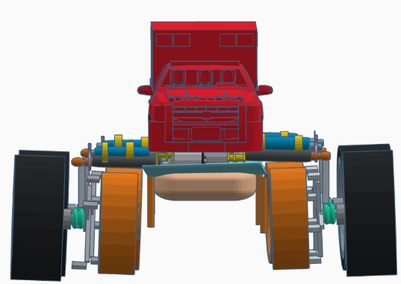

# Figure.2 Flying Position of Air Ambulance

# C:\Users\Karthik Pandiyan\Pictures\Screenshots\Screenshot (227).png

# Figure.3 Water Floating Position of Air Ambulance

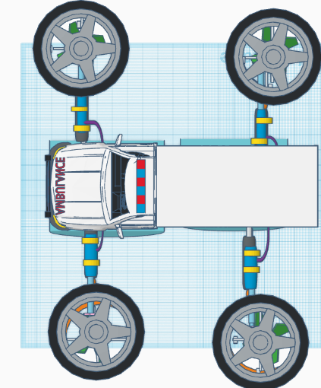

When this ambulance moves on the road, it moves like any other vehicle. The ambulance senses a traffic signal from a short distance away and inflates all the side air bags with helium gas. When there is a traffic jam, the drones mounted on the underside of the wheels will rise and fly; When there is a traffic jam, the drones will start spinning and the vehicle will start moving from the air.

If this vehicle is not able to pass over and go on the road, it can easily go on water. Once the vehicle reaches the water level, the vehicle can be changed to the direction of flight with the help of four rods fixed on the side of the vehicle. The vehicle floats on the water with the help of an airbag mounted on the bottom of the vehicle. It is easy to tell in water as the first two wheels turn 20 degrees and the back two wheels turn 30 degree.

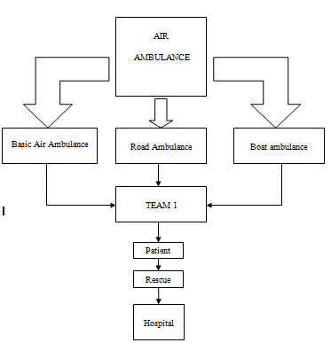

# Figure.5 Process of Air Ambulance

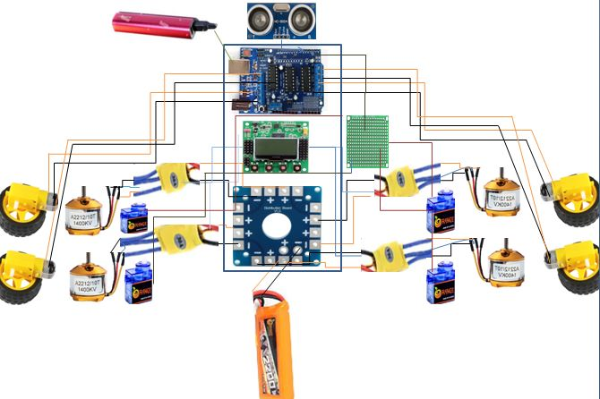

**Figure.6 Block diagram of the Invention**

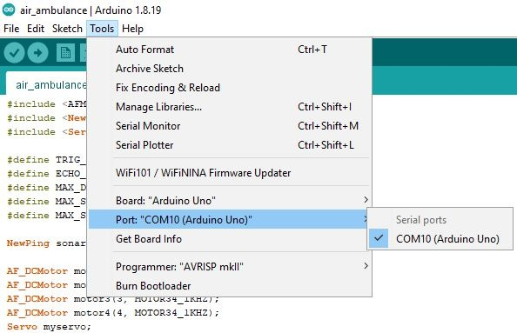

# Figure.7Arduino IDE Simulation

**TARGET CUSTOMER**

**Health Care :** This project will be important in the health sector. This vehicle can immediately save the victim's life by transporting him to the hospital. The initiative will primarily benefit the elderly and road accident victims.

**Transports:** This project will play an important role for humanity as it can reduce the road traffic congestion in our country by using it in all transport vehicles for medical service and not thereby reducing air pollution and noise pollution.

**Cost Analysis**

**Material Cost:**

|  |  |  |  |  |
| --- | --- | --- | --- | --- |
| S.N O | DESCRIPTION | QTY | MATERIAL | AMOUNT(RS) |
| 1 | Aluminium sheet( side 4\9)( Top 3\9) | 6 | Aluminium | 20,000 |
| 2 | Thermocol sheet | 35 | Thermocol | 6,000 |
| 3 | Drone Motor | 4 | Steel | 80,000 |
| 4 | Drone propeller | 4 | Fiber | 20,000 |
| 5 | Helium gas (cylinder) | 1 | Gas | 20,000 |
| 6 | Air bags(side 3\8)Top(2\9) | 4 | Rupper(PVC) | 10,000 |

|  |  |  |  |  |
| --- | --- | --- | --- | --- |
| 7 | Nor mal mid range vechicle | 1 | Iorn | 100,000 |
| 8 | Other material and component | ----- | All | 50,000 |
| Total | | | | 306,000 |

**WORK PLAN:**

The materials for this project may take one to two weeks to get. A minimum of 4 to 5 manpower is required to complete this project and the project varies depending on manpower. It will take at least three to four weeks to complete this work. Many people's lives can be restored as a result of the implementation of this initiative. Road congestion can readily alleviated. This endeavour will make a significant contribution to our country.